

***Volunteers Handbook***

**Name:** _____________________________________

**Shifts:** _____________________________________

_____________________________________

_____________________________________

_____________________________________

|  |
| --- |
| **VOLUNTEER HOTLINE 49 210 300** |





***MESSAGE FROM THE MAYOR***

*Welcome to the Lake Macquarie 2014 International Children’s Games! Here in Lake Macquarie, we are excited about being the first city in the southern hemisphere to host the International Children’s Games. In December we will be welcoming young athletes from around the world, representing 80 cities.*

*As well as an intensive three days of sporting competition, we have planned some amazing activities for the children which will give them an insight to our Australian way of life, and provide them with the opportunity to make new friends from around the world.*

*None of this would be possible without a dedicated team of enthusiastic volunteers, and on behalf of the City of Lake Macquarie I thank you for volunteering your time and talents to help make these Games a success. It will be challenging and at times, demanding. However I’m sure that it will be immensely rewarding and an unforgettable experience for you.*

*Let the Games begin!*

*Cr Jodie Harrison / Mayor of Lake Macquarie*

**

**

**Contents**

|  |  |  |  |  |
| --- | --- | --- | --- | --- |
| **ICG Overview** | 4 |  | **Job Descriptions (continued)** |  |
| **2014 Games Timetable** | 5 |  | Hospitality and Schools | 20 |
| **Information on Lake Macquarie** | 6 |  | Meet and Greet | 21 |
| **Event Hub** | 8 |  | Marshals | 22 |
| **Free Games Shuttle Bus** | 8 |  | * University Accommodation |  |
| **Attributes of a Good Volunteer** | 9 |  | * Opening Ceremony |  |
| **When you arrive at your venue ….** | 11 |  | * Swimming Grandstand |  |
| **If you are unable to attend ….** | 11 |  | * Gymnastics |  |
| **Job Descriptions** |  |  | * Athletics |  |
| City Team Liaison Officer (CTLO) | 12 |  | * Closing Ceremony |  |
| Venue Manager | 13 |  | Games Operations Centre Sports Results | 24 |
| Risk Manager | 13 |  | Medal Ceremonies | 24 |
| Volunteer Services | 14 |  | **Venues** |  |
| Transport | 14 |  | Meet & Greet – Airport and Train | 25 |
| * Sporting Venues |  |  | University Accom. & Movie Night | 26 |
| * University Accommodation |  |  | Myuna Bay Accom. & Movie Night | 28 |
| * Opening Ceremony |  |  | ICG Opening Ceremony | 29 |
| * Blacksmiths Beach Experience |  |  | ICG Beach Experience | 30 |
| * Closing Ceremony |  |  | Athletics and Gymnastics | 31 |
| Catering | 16 |  | Swimming | 33 |
| * All venues (except accom.) |  |  | Golf | 35 |
| * Accommodation venues |  |  | BMX | 37 |
| Medical | 17 |  | Sailing | 39 |
| Audio Visual | 17 |  | Water Polo | 41 |
| Game Day Registration | 17 |  | Football | 43 |
| Rego and Info. at accommodations | 18 |  | ICG Closing Ceremony | 45 |
| Information and Merchandising | 19 |  |  |  |
| Media | 20 |  | **Incident Report Form** | 46 |

****ICG Overview**

***History of the International Children’s Games***

The International Children’s Games were started in 1968 in Slovenia by a PE teacher Metod Klemenc, who had a vision to promote peace and friendship through sports to the world’s youth. The 2014 Games in Lake Macquarie will be the 48th Summer Games. Lake Macquarie has competed in San Francisco, Bahrain, Lanarkshire, Daegu and Windsor.

***Facts and figures***

**80 cities** from **30 countries**, involving approximately **1,500 athletes, representatives and officials**, will be attending. They will be accommodated at the University of Newcastle and at Myuna Bay Sport and Recreation Centre. Competitors will compete in **8 sports**:

**Athletics** **and Gymnastics** at the Hunter Sports Centre in Glendale,

**Swimming** at the Forum Sports and Aquatic Centre at the University of Newcastle,

**Golf** at Waratah Golf Club in Argenton,

**BMX** at the Argenton BMX Track,

**Sailing** in Belmont Bay, from Belmont 16’ Sailing Club

**Water Polo** at Speers Point Pool, adjacent to the Event Hub in Speers Point Park,

**Football** at the Lake Macquarie Regional Football Facility, at Speers Point, and

An estimated **3000 family members and supporters** will visit Lake Macquarie during the Games.

**

***Competing cities, and where they will be staying:***

*(All staying at University except MB = Myuna Bay)*

|  |  |  |  |  |
| --- | --- | --- | --- | --- |
| *Berrigan* | *Canberra* | *Clarence Valley (MB)* | *Gosford* | *Hobart* |
| *Lake Macquarie* | *Launceston (MB)* | *Lismore* | *Maitland* | *Newcastle* |
| *Pittwater* | *Shellharbour* | *Singleton* | *Upper Hunter* | *Graz* |
| *Innsbruck* | *Hamilton* | *Kelowna* | *Kitchener* | *Lakeshore (MB)* |
| *Waterloo* | *Windsor* | *Beijing* | *Macau* | *San Marcos* |
| *Osijek* | *Karlovy Vary* | *Leicester* | *Darmstadt* | *Freiberg* |
| *Patras* | *Sparta (MB)* | *Kecskemet* | *Sopron* | *Szombathely* |
| *Bangalore* | *New Delhi* | *Tralee* | *Emek Hefer (MB)* | *Hadera (MB)* |
| *Raanana* | *Kaunas* | *Aguascalientes* | *Distrito Federal* | *Puebla* |
| *Queretaro* | *San Luis Potosi* | *Toluca* | *Alkmaar* | *Napier* |
| *Karachi* | *Kasur* | *Lahore* | *Sialkot* | *Plock* |
| *Tula* | *Ufa (MB)* | *Yekaterinburg* | *Singapore* | *North Lanarkshire* |
| *Celje* | *Ptuj (MB)* | *Slovenj Gradec (MB)* | *Velenge* | *Daegu (MB)* |
| *Seoul* | *Delemont (MB)* | *Lausanne* | *Montreux* | *Vevey* |
| *Bangkok* | *New Taipei City* | *Taipei* | *Uzhgorod* | *Chesterfield* |
| *Cleveland (MB)* | *Contra Costa (MB)* | *Los Angeles (MB)* | *Marion* | *Oakland (MB)* |

**2014 Games Timetable**

(Saturday 6 December – arrive at accommodation)

|  |  |  |  |  |
| --- | --- | --- | --- | --- |
|  | *Sunday* | *Monday* | *Tuesday* | *Wednesday* |
| *Opening Ceremony* | *Speers Pt Park* |  |  |  |
| *Athletics* | *Training* | *Competition* | *Competition* | *Competition* |
| *Gymnastics* | *Training* | *Competition* | *Competition* | *Rest Day* |
| *Swimming* | *Training* | *Competition* | *Competition* | *Competition* |
| *Golf* | *Training* | *Competition* | *Competition* | *Rest Day* |
| *BMX* | *Training* | *Training* | *Rest Day* | *Competition* |
| *Sailing* | *Training* | *Competition* | *Competition* | *Competition* |
| *Water Polo* | *Training* | *Competition* | *Competition* | *Competition* |
| *Football* | *Training* | *Competition* | *Competition* | *Competition* |
| *Movie Night* |  | *Accommodations* |  |  |
| *Beach Experience* |  |  | *Blacksmiths* |  |
| *Closing Ceremony* |  |  |  | *University* |

(Thursday 11 December – depart accommodation)

**

**Information on Lake Macquarie**

*As a representative of the City of Lake Macquarie you may be asked to provide information about the city. Here is some information which you could pass on to our guests:*

***Location***

Lake Macquarie is 150 kms (93 miles) or approximately 2 hours north of the state capital, Sydney and is adjacent to the city of Newcastle

***Original Inhabitants***

Aborigines of the Awabakal nation were the original inhabitants of the area, living here for thousands of years before European settlement around 1826.

***Population***

Lake Macquarie is one of the largest cities in NSW with a population of approximately 200,000 people. It is unique in that it is made up of 92 villages or suburbs, which range from small rural communities to larger, high-density towns.

***Economy***

* Lake Macquarie has developed into a major hub for small to medium size business with knowledge and technology-based industries exhibiting strong growth.
* The three leading industries as a proportion of employment in Lake Macquarie are retail trade 17.7%; manufacturing 12.3%; Health and Community Services 12%
* Two major retail centres in the city offer favourite chain stores and national brands and are located at Charlestown and Glendale. The Glendale centre is next to the Athletics and Gymnastics venues. Many of the other relaxed town centres offer arts, crafts and boutique shopping.

***Major natural features***

* Centrepiece of the city is the largest coastal saltwater lake in Australia**. Lake Macquarie** is a tidal lakeand twice the size of Sydney Harbour, including 170km of foreshore. The maximum depth of the lake is 11 metres with the average depth about 8 metres.
* The **Watagan Mountains** can be found on the western side of Lake Macquarie and incorporate 13 forests, numerous outlooks, picnic spots, camping areas and magnificent waterfalls.
* **Four patrolled surfing beaches** form the east coast of the city and stretch over 10 kms. The Beach Experience event will be held at Blacksmiths Beach.

***Recreation:***

Lake Macquarie provides a natural playground to residents and visitors for sailing, fishing, surfing, bushwalking, picnicking, camping and many other recreational activities.

***Transport services***

*All volunteers will be expected to make their own way to and from their appointed venue each day.*

(If you are attending the Opening Ceremony on Sunday 7 December, there will be a free ***Park and Ride*** service for all volunteers and the general public, operating from Warners Bay shopping centre car park.)

For all other transport needs:

* Newcastle Buses: [www.newcastlebuses.info/](http://www.newcastlebuses.info/)
* Newcastle Taxis: telephone 133 300,
* Newcastle Hire Cars: telephone 02 4960 1800

**Event Hub**

The Event Hub is located at Speers Point Park. It is the social heart of the Games, and all volunteers are encouraged to gather at the Hub to celebrate their Games Experience, whenever they are not rostered for their shift. At the Hub there will be a large screen which will provide coverage from a number of sporting venues.

C:\Users\djwilliams\AppData\Local\Microsoft\Windows\Temporary Internet Files\Content.IE5\LDKKTR60\MM900286822[1].gif

**Free Games Shuttle Bus**

If you are not rostered for any duties, you are encouraged to come to the Event Hub and take advantage of the free Games Shuttle Bus Service, which will be travelling on a loop which will include the Event Hub and all competition venues, except the sailing venue at Belmont Bay. This service will be running from Sunday 7 December through to Wednesday 10 December, approximately every 30 minutes, from around 9.00am to around 3.00pm each day.

C:\Users\djwilliams\AppData\Local\Microsoft\Windows\Temporary Internet Files\Content.IE5\LDKKTR60\MC900388712[1].wmf

**

**Attributes of a Good Volunteer**

***Cultural Awareness***

* Give people time to explain their needs, put yourself in their place and consider what their needs are
* If necessary, repeat what they are requesting to ensure you understand
* Use maps, diagrams and pictures
* Be respectful, friendly and always smile

***Working in a Team***

* Make sure you understand the chain of command, and get to know your supervisor
* Contribute to briefings and de-briefings
* Help others within your team to do their job
* Arrive with an open mind – you may be asked to do a role that you are not initially familiar with
* Ask questions if you don’t understand something

***Media***

During the Games there will be representatives of the media conducting interviews at all of the sports venues and also at the Event Hub. If a media person approaches you while you are volunteering, please refer them to the Venue Manager, who will be able to refer them to the appropriate person.

***Accreditation Pass***

* Must be worn at all times that you are rostered on
* Includes details on what access you have to each venue
* Includes a list of important contacts

***Safety Awareness***

Emergency procedures

Each venue has an Emergency Response Plan in case there is an emergency at the venue. You will be briefed on the Plan at your venue induction on Friday 5 December. You may be asked to assist the Venue Manager in responding to the emergency. You should always be aware of the location of the Meeting Point if the venue has to be evacuated. This is indicated on each Venue Map within this booklet.

Severe weather

Venue Managers will be monitoring weather forecasts during the Games and if there is a risk of severe weather then this will be discussed at the start of your shift. In the event of severe weather you may be asked to proceed to a safe place to avoid the weather. This may also involve assisting athletes and spectators to proceed safely. Do not resume your original position until you have been advised by the Venue Manager that it is safe to do so.

Incident report

There will be a strong police presence at every venue to deter or respond to any unlawful behaviour. Also, every venue will have professional medical staff who can provide appropriate treatment if there are any injuries. Notwithstanding this, an incident or accident may occur in the area that you are volunteering. Firstly it is important to ensure that you do not put yourself at any risk before you attempt to assist any injured people. If you observe an incident, accident or suspicious behaviour you should report it to your supervisor or the Venue Manager. There is an Incident Report Form within this booklet which can assist you to collect details of the incident or the accident.

Dehydration

Most of the events are being held outdoors during December, which means that many of the volunteer roles will be outdoors in the sun. It is therefore very important to stay hydrated throughout your volunteer shift. We recommend that you carry your ICG water bottle with you wherever you are volunteering. If you are working outdoors and you become hot, thirsty and tired you should immediately get out of the sun and have a rest. Also please keep an eye out for any other volunteers that may be showing signs of dehydration, such as lethargy, confusion and rapid pulse.

Non Smoking and Alcohol Policies

All of the games venues, with the exception of some clearly designated areas, are non-smoking and alcohol-free venues. If you see anyone violating these policies please advise your supervisor.

Security

All aspects of the Games have been reviewed by a security committee with the assistance of NSW Police. Each venue will have uniformed and non-uniformed police present. At the major gatherings this will be supplemented by contract security staff. Your safety and the safety of the athletes will be our highest priority.

Child protection

Please be observant for suspicious behaviour, or the presence of “undesirable persons”. You can assist in keeping our athletes safe by being vigilant and immediately reporting any suspicious behaviour to a security officer in the first instance and then to your supervisor. Remember that you should never place yourself in a one-on-one situation with a child.

Manual handling

If you are required to lift something please do so in a safe manner. There is a right and a wrong way to lift. Use a trolley / Lift in teams / Keep your knees bent and back straight / Use a firm grip.

Complaints / discipline procedure

Your engagement as a volunteer is under the Lake Macquarie Council’s Volunteer Engagement protocol. As such, there are established complaints and discipline procedures which are consistent with Council’s HR procedures. Further information can be obtained from your Venue Manager.

**When you arrive at your venue….**

***Check-in***

When you arrive at the venue, go to the Volunteer Services desk to sign in – it will be identified by signage at the venue. Also, check the Venue Maps in this booklet. The check-in steps are:

C:\Users\djwilliams\AppData\Local\Microsoft\Windows\Temporary Internet Files\Content.IE5\Q0YOTJYL\MC900334014[1].wmf

1. Sign your name on the roster
2. You will be directed to meet your supervisor
3. Your supervisor will give you an onsite briefing on how to safely perform your role
4. You will be directed to your location

**VOLUNTEER SERVICES**

*Don’t forget to wear your uniform and your accreditation pass at all times that you are volunteering, and be prepared for the weather!*

***Check-out***

At the completion of your shift, you must check-out at the Volunteer Services desk

**If you are unable to attend your venue….**

We understand that circumstances can arise which mean that you cannot attend the venue. In this case, please ring the Volunteer Hotline on **49 210300** as soon as practicable.

**Job Description – City Team Liaison Officer (CTLO)**

(Reports to the Hospitality Coordinator, Angela O’Brien).

This role is a key relational and communication role.

One CTLO per City Team for the duration of the Games (HoD = Head of Delegation)

Ideally, the CTLO will understand the Team’s primary language. If not, a volunteer interpreter may be appointed to assist.

**Prior to Games**

Ideally, makes contact with HoD in the weeks leading up to the Games (via email, Facebook, etc)

**Friday**

**7am – 12pm**

* Check-in at Volunteer Registration Desk at your Team’s accommodation (University OR Myuna Bay)
* Venue Induction
* Picks up Welcome Bags from Rego Marquee and Linen Packs from on-site trolleys and delivers to rooms
* Makes beds (bottom sheet only), assisted by other CTLOs and volunteers

**Saturday**

* Meets team at accommodation (check team travel schedule for estimated arrival time)
* Accompanies team to registration and assists HoD with registration (includes hand out of keys and credit card swipe)
* Ensures that all athletes are safely installed in their rooms
* Attends Opening Ceremony dress rehearsal at Speers Point Park at 4.30pm (this takes precedence over waiting for the Team to arrive at the accommodation)

**Sunday**

**University Accommodation: 6.30am** - Meets the HoD and coaches at the accommodation registration tent, then directs HoD and coaches to the walking route to The Forum, so that they can attend 7am morning meetings at the Forum. Transport volunteers will man the walking route. CTLOs remain at the accommodation.

**Myuna Bay Accommodation: 6.15am** - Meets the HoD and coaches at the accommodation registration desk, then directs them to the buses which will take them to morning meetings at the University Forum. The buses must depart by 6.30am.

**Up to 9.00am (approx.) - R**emains at accommodation. During this time, there will be no coaches or HoD at the accommodation. Please monitor childrens’ behaviour in dining room and encourage them to prepare to attend their respective training venues

**From 9.00am**

* Accompanies HoD, coaches and Team to training venues, as required, via the bus from accommodation.
* Lunch at the training venues

**From 2.00pm** - Accompanies team back to accommodation via bus.

**3.30pm**

* Accompanies Team to Opening Ceremony at Speers Point Park via bus
* Leads the Team at the Opening Ceremony march past, sits with the Team at the Opening Ceremony, and eats with the Team after the Ceremony

**7.30pm** - Accompanies Team back to accommodation via bus

**Monday to Wednesday**

* Continues to build a good relationship with the HoD
* Preferably, will meet up with the delegation wherever their athletes are competing, but this is not essential

**Wednesday Night** - Along with all other volunteers, you are invited to attend the Closing Ceremony, to be held outside The Forum, on Wednesday evening. You will have no formal duties to perform.

**Job Description - Venue Manager**

(Check the Event Schedule for your venue, which will show your shift times)

* Main point of contact for the Venue Owner and also ICG Administration
* Assists in the delivery of the Site Induction to all volunteers prior to the Games
* Liaises closely with the Venue Owner re use of facilities etc
* Responsible for all event staff at the venue
* Advises the Event Director and Operations Manager immediately if there is an incident at the venue
* Emergency Controller if Venue Owner unavailable
* Main point of contact for ICG Administration
* Counter-signs all Incident Reports
* Provides a daily report to Operations Manager via phone from the ICG template
* Is familiar with the ICG Risk Management Plan and the venue Emergency PlanReports to the ICG Operations Manager

**Job Description - Risk Manager**

(Check the Event Schedule for your venue, which will show your shift times)

* Reports to the Venue Manager
* Also takes direction from the ICG Risk Manager – Col Bartley
* Undergoes specific Venue Risk Manager training prior to the Games
* Ensures that all non-sport activities are conducted in a safe environment, including safe pathways to and from bus stops
* Is responsible for ensuring that all WHS practices are complied with, such as training in specialist practices and completion of Safe Work Method Statements, where applicable
* Is responsible for implementing the Traffic Management Plan for the venue each day
* Conducts pre-competition and during competition security sweeps
* Liaises with Technical Director regarding weather safety
* Ensures that all venue risk management control measures are in place throughout the day
* Takes the lead in the completion of Incident Reports related to the venue, and then immediately forwards completed reports to the Venue Manager
* Is familiar with the ICG Risk Management Plan and the venue Emergency Plan
* Conducts a daily safety talk for all volunteers at the beginning of each day.

**Job Description - Volunteer Services**

(Check the Event Schedule for your venue, which will show your shift times)

As a venue Volunteer Services Team Leader, you will report to the Venue Manager and be responsible for the welfare of all volunteers at the venue. This will require carrying out the following duties:

* Distribution of handbooks, shirts and caps to all volunteers at the pre-Games venue induction
* Daily check-in and check-out of all volunteers
* Ensures that each volunteer signs the volunteer roster at the start of each shift
* Ensures that all volunteer functional areas are sufficiently staffed – this may require prioritising and reallocating roles on the volunteer roster throughout the day
* Ensures that the event is sufficiently serviced while also managing volunteer lunch breaks and fatigue breaks
* Regular monitoring of volunteer activity, health and welfare throughout each day
* End-of-shift report to Venue Manager

**Job Description - Transport**

Team Leader Roles:

* Team Leader reports to the Venue Manager
* Also takes direction from the ICG Transport Coordinator – Bob Porter
* Team Leader undergoes specific functional area training in Transport operations
* The Team Leader liaises with Transport Coordinator to ensure timely arrival of buses for pickup and departure of competitors
* Ensures that Transport volunteers are in position to welcome and farewell buses

If allocated to a sporting venue:

(Check the Event Schedule for your sporting venue which will show your shift times)

* Sign on at the Volunteer Services desk
* Your role is to meet the buses at the bus drop-off point and direct the athletes to the athlete registration desk
* Once the athletes are settled at the venue, you are encouraged to enjoy the sporting competition, while being available to assist in any other duties
* You may be requested to assist in marshalling the athletes for their competition, or to assist in the distribution of lunches
* You may be requested to assist in the Awards Ceremonies.
* At the end of each day’s competition you will assist in the orderly and safe boarding of buses. Coloured lanyards will determine where each competitor’s accommodation is, therefore which bus to catch.
* After the teams have left the venue you may be asked to assist in cleaning up any rubbish that they have left.

*Above all, you should encourage and support the competitors and take an active interest in their enjoyment and safety.*

If allocated to the University accommodation:

(Shifts - Sunday: 8.00am to 10.00am, and Monday to Wednesday: 7.30am to 10.00am)

* Sign on with Volunteer Services, located in the marquee at the University accommodation
* Go to the bus stop on University Drive and assist in the orderly loading of children and coaches onto each bus

(There will be a lay down area for buses to the west of the bus stop. When each bus is full, another bus will drive to the bus stop. When all children and coaches have been loaded – around 9am - contact the Transport Supervisor)

* Sign out with Volunteer Services

If allocated to the Opening Ceremony:

(Shift: Sunday 4.00pm to 9.00pm approx.)

* Sign in with Volunteer Services
* Your role will be to assist in the unloading off athletes from their buses as they arrive for the Opening Ceremony, and directing them towards their assembly area
* When all the buses have delivered the athletes, you are requested to assist in the marshalling of the athletes in their assembly area
* During the ceremony you may be requested to assist with other marshalling activities
* After the ceremony you will escort the athletes to their dinner venue, which is in a private area adjacent to the ceremony
* After dinner you will assist in the orderly departure of the athletes onto their buses

If allocated to Blacksmiths Beach Experience:

(Shift: Tuesday 4.00pm to 8.00pm approx.)

* Sign in with Volunteer Services
* Your role will be to assist in the unloading off athletes from their buses as they arrive for the Beach Experience, and directing them towards the Beach
* As buses unload, transport volunteers will walk with the athletes to the beach and take up their positions on the perimeter of the beach activity area. By the time that the last bus has arrived, only a couple of transport volunteers will be remaining at the drop-off point.
* During the Beach Experience you will be positioned at the perimeter of the beach activity area, ensuring that the children do not leave the area.
* The public toilets will be out-of-bounds for the children – there will be port-a-loos located within the perimeter for them to use.
* At the completion of the Beach Experience, transport volunteers will form a human corridor from the surf Club to the bus stop.

If allocated to the Closing Ceremony:

(Shift: Wednesday 6.00pm to 9.30pm approx.)

* Sign in with Volunteer Services, located in the Forum, then make your way up to the Forum Car Park
* Your role will be to greet the athletes’ buses from Myuna Bay which will arrive at the Forum car park, and direct the athletes to the entry gate of No. 2 Oval – about 5 to 6 buses are expected.
* Please enjoy the Closing Ceremony
* After the Closing Ceremony your role will be to ensure that the Myuna Bay athletes are safely boarding their buses.

**Job Description - Catering**

**Team Leader**

* Reports to the Venue Manager
* Also takes direction from the ICG Venue Catering Coordinator – Bronwyn Sheldon
* Undergoes specific functional area training in catering
* Liaises with Venue Manager / Venue Owner to clean up the venue after lunches are completed
* Provides feedback to Venue Manager on the condition of hydration points and port-a-loos
* Manages the daily clean-up, puts bins out etc (some venues may carry out this activity themselves)

**General Catering Volunteer**

(Check the Event Schedule for your venue which will show your shift times)

* Sign in at the Volunteer Services Desk
* Sets up the food service area at the venue
* Daily collection of meals and drinks from the supplier drop-off point.
* Ensures that drinks stations are set up, where applicable.
* Note that volunteers food collection point and dining area should be separate to competitors
* Competitors should take priority over volunteers
* Throughout the day, ensures that hydration points are workable, and monitors the condition of toilets and port-a-loos
* Cleans up after lunch
* Is not responsible for cleaning up port-a-loos and toilets (will be done by contractors)

**Catering Volunteer at Accommodation Venues only**

(Shifts: Sunday to Thursday- 6.00am to 9.00am, and 2.30pm to 5.30pm)

* Sign in at the Volunteer Services desk
* Your role is to provide snacks to the athletes
  + after they have finished breakfast, and
  + when they return from their sport

**Job Description - Medical (First aid, nurses, physios)**

Your role and responsibilites will be explained in detail at a separate briefing session conducted by the Chief Medical Officer.

**Job Description - Audio Visual**

(Check the Event Schedule for your venue, which will show your shift times)

* Reports to the Venue Manager
* Undergoes specific functional area training in Awards Ceremonies
* Manages the PA system and automated messages
* Liaises with Chief Official, Marshals, Team Liaison and Hospitality
* Sets up the podium
* Confirms correct awards recipients from the Technical Delegate
* Provides pre-recorded announcements throughout each day
* May “call” the event in progress, if one is not provided by the Sport
* May announce the medal presentations, if one is not provided by the Sport

**Job Description – Game Day Registration**

(Check the Event Schedule for your venue, which will show your shift times)

* Team Leader reports to the Venue Manager
* Team Leader undergoes specific functional area registration training prior to the Games
* May assist venue staff with registering athletes, or may manage the process themselves
* Deals with all registration and accreditation issues at the sporting venue, eg, if a competitor has left his accreditation back at the accommodation venue
* Provides media accreditation if requested by the Games Operations Centre

**Job Description – Registration and Information at Athletes’ Accommodation & VIP Accommodation**

*Prior to Friday, ICG staff will deliver the following to the Registration and Information area:*

* *Guest welcome bags*
* *Head of Delegation (HoD) information packs*
* *Computers, printers, internet access*
* *Information brochures etc*

*The Guest Welcome Bags will be distributed to the rooms by each team’s CTLO on Friday morning.*

**Friday 3.00pm – 6.00pm:**

Sign on with Volunteer Services,.

Check the contents of each HoD information pack, that it contains:

* A list of each delegation’s members and room nos.
* An envelope for each guest, containing room key, lanyard, accreditation card and venue map
* HoD information booklet

Set up registration desk, information desk, signage etc in preparation for the arrival of guests on Saturday.

At 5.00pm there will be a venue induction (University and Myuna Bay only).

**SATURDAY**

**Morning Shift: 7.00am – 3.00pm, and**

**Afternoon Shift: 2.00pm - 10.00pm**

Sign on with Volunteer Services

Register teams via the event on-line management system

Hand out information packs to HoDs

If a Team’s CTLO is unavailable, you may be required to accompany the Team to its rooms on Saturday

Provide event info and local info throughout the Games

At the end of each day, ensure all equipment is secure and notify Venue Manager

**SUNDAY**

**Morning Shift: 6.00am – 1.00pm**

**Afternoon Shift: 1.00pm – 6.00pm**

**Night Shift: 5.00pm – 9.30pm**

Sign on with Volunteer Services

** (AT UNIVERSITY ONLY: 3 registration volunteers to proceed directly to The Forum, where they will register the attendance of all HoDs and Coaches to the Technical Meetings, which commence at 7.00am. This role should be completed by 8.00am).

Remaining Registration and Information volunteers to be stationed at the accommodation Registration and Information desk.

Provide event info and local info throughout the Games

Ensure all equipment is secure and notify Venue Manager at the end of each day

**MONDAY**

**Morning Shift: 7.00am – 1.00pm**

**Afternoon Shift: 12.00pm – 6.00pm**

**Night Shift: 5.00pm – 9.00pm**

**TUESDAY**

**Morning Shift: 7.00am – 1.00pm**

**Afternoon Shift: 12.00pm – 6.00pm**

**WEDNESDAY**

**Morning Shift: 7.00am – 1.00pm**

**Afternoon Shift: 12.00pm – 6.00pm**

**Night Shift: 5.00pm – 10.00pm**

**THURSDAY**

**Shift: 7.00am – 2.00pm**

**Job Description - Information and Merchandising**

(Check the Event Schedule for your venue, which will show your shift times)

**Information**

As Team Leader, you will report to the Venue Manager and undergo specific functional area Information and Merchandising training, where you will be provided with an Information Services manual

* It is expected that you will come to the venue prepared with some knowledge of the sport, the venue and surrounding areas
* Provides general information to competitors and the public, such as local facilities, transport, tourism etc.
* Liaises with Results to obtain sporting information throughout the day

**Merchandising**

At selected games venues there will be a merchandising desk, and it is expected that information and merchandising duties will be shared from time to time. Throughout each day Games staff will visit the desk to ensure that you are well stocked. Merchandising involves

* the sale of all Games related merchandise at the venue, such as mascots, key rings, pins, caps etc
* Reconciliation of sales and takings at the end of each day
* Report back to the Venue Manager at the end of each day

**Job Description - Media**

(Check the Event Schedule for your venue which will show your shift times)

* All media volunteers will be required to undergo media specific training
* Reports to the Venue Manager
* Provides regular media releases back to Ops Centre
* Uploads results, images and videos directly to social media
* Liaises with “Information” to obtain information

**Job Description - Hospitality and Schools**

This role involves the provision of hospitality services to VIPs and also accompanying visiting schools while they are at the venue.

(Check the Event Schedule for your venue, which will show your shift times)

**Hospitality**

Each venue will have a hospitality area for the comfort of VIPs, such as city Lord Mayors. All VIPs will be specifically accredited which will be identifiable on their accreditation tags. It is expected that most VIPs will wish to mingle with their delegations, but it is important to acknowledge their arrival and escort them to seating or guide them to get refreshments. You will be required to have a working knowledge of the venue, its facilities and the competition schedule as it takes place to be able to answer VIP questions.

**Schools**

All venues (except swimming) will have sufficient space to accommodate schools’ visits. All schools will be encouraged to register their interest in visiting so that a daily Schools Schedule will be developed, however some schools may turn up unannounced. You will be required to meet and greet visiting schools and then escort them to the designated schools area.

**Job Description - Meet and Greet**

(Reports to the Hospitality Coordinator, Angela O’Brien).

**Newcastle Airport – Saturday 6 December**

(First shift: 7.00am – 1.00pm, Second shift: 1.00pm – 7.00pm)

Our volunteers will be at the airport to welcome and greet teams.

When the plane arrives, hold the ICG sign up to attract their attention

Greet each team and show them through to their bus to accommodation.

After each team is placed on the bus, please advise the Registration Manager who is based at the Team’s accommodation.

If bus is unavailable, contact the Bus Company representative

Stay at airport to greet the next team

**Newcastle Train Station – Saturday 6 December**

(First shift: 7.00am – 1.00pm, Second shift: 1.00pm – 7.00pm)

Our volunteers will be at Newcastle train station to welcome and greet teams.

When the Sydney train arrives, hold the ICG sign up to attract their attention

Greet each team and show them through to their bus to accommodation.

After each team is placed on the bus, please advise the Registration Manager who is based at the Team’s accommodation.

If bus is unavailable, contact the Bus Company representative

Stay at the train station to greet the next team.

**Job Description – Marshals**

**University Accommodation Marshals**

(First Shjft: Sunday: 6.00am – 7.30am)

*All Heads of Delegation (HoD) and Coaches are required to attend a 7am meeting at the Forum*

Sign on with Volunteer Services, located in the marquee at the University accommodation. Familiarise yourself with the walking route from accommodation to The Forum.

Take instructions on where your position is along the walking route, and go to that position (suggest that you bring a fold up chair and a sun hat).

Provide directions to the location of the Forum. Note that the route will also have signposting at strategic locations.

* Be aware that you do not have the power to manage any traffic on the route. Everyone is to use paths and pedestrian crossings along the route.

Sign off with Volunteer Services at the completion of your shift.

(Second Shift: Monday: 6.00pm – 9.30pm (approx.))

*All children will be invited to a movie night, to be held from 7pm on University No. 1 Oval on Monday night*

Sign on with Volunteer Services.

Take instructions on where your position is along the walking route, and go to that position (suggest that you bring a fold up chair).

Provide directions to the location of the Movie Night. Note that the route will also have signposting at strategic locations.

* Be aware that you do not have the authority to manage any traffic on the route. Everyone is to use paths and pedestrian crossings along the route.

While the movie is playing, position yourself around the perimeter of the audience, and enjoy the movie! You may be requested to provide directions to the toilets. You must not accompany any child to the toilet unless there is someone else (child or adult) with you!

At the completion of the movie, return to your designated position along the route, and provide directions back to the accommodation. Note that the route will be illuminated by portable light towers.

Sign off with Volunteer Services at the completion of your shift.

**Opening Ceremony Marshals**

(Shift: Sunday: 3.00pm – 10.00pm (approx.))

Note: If you are required to attend the 4.00pm rehearsal on Saturday, you will be notified directly by ICG Event Staff.

*All athletes, coaches and team managers will be attending the Opening Ceremony, to be held from 5pm at Speers Point Park. This is a free event and is open to the general public. Immediately following the Opening Ceremony, the annual Lake Macquarie Carols by Candlelight celebrations will take place.*

*At the conclusion of the Opening Ceremony the children will be escorted from their seats to a private area at Speers Point Park, where they will be served dinner. After dinner, at around 9.00pm, the children and their delegation will be transported to their accommodation, either to Newcastle University or Myuna Bay.*

When you arrive at the park, please sign on at the Volunteer Services Desk, which will be identified by signage.

You will be allocated one or more of the following roles:

* Prior to the Ceremony, walking around the park, or standing at the park entry points, providing Opening Ceremony programs to the general public
* Assisting with marshalling the athletes before the Ceremony, and as they march to their seats
* Standing in the zone between the athletes seating and the general public, providing yourself as a visible barrier
* Assisting with marshalling the athletes after the Ceremony, and as they march to their seats

**Swimming – Grandstand Marshals**

*At the swimming venue, there will be a public grandstand which is next to the athletes’ seating.*

Your role will be to ensure that members of the public, including families and supporters, do not proceed into the swimmers’ area.

**Gymnastics FOP Marshals**

Your role will be to assist the technical staff with the presentation of the equipment, as well as to assist in marshalling the competitors.

**Athletics – Foyer Marshals**

Your role will be to ensure that athletes, coaches, members of the public etc do not go into restricted areas within the foyer of the Hunter Sports Centre. Additionally, you will perform a general marshalling role at the venue.

**Closing Ceremony Marshals**

(Shift: Wednesday 6.00pm – 10.00pm (approx.))

*All athletes will be attending the Closing Ceremony, to be held from 7pm on No. 2 Oval, which is outside The Forum on Wednesday night. Around 1200 children and coaches will be walking between the University accommodation and the Forum. Additionally, 4 marshals will be required back-of-stage to help coordinate the entertainment.*

When you arrive at the Forum, please sign on with Volunteer Services, located in or near the Forum foyer.

You will be allocated one of the following roles:

* 4 marshals are to proceed to the accommodation car park, and assist in directing the teams on the path to the forum. You should be at the accommodation by 6.15pm. Note that the route will also have signposting at strategic locations. After most of the teams have left the accommodation, the 4 marshals are to accompany them up to No. 2 Oval. When they reach the venue, these 4 marshals are to provide “back-of-stage” assistance for the entertainment.
* 10 marshals are to remain at the Forum, and when the Teams arrive at the venue, these 10 marshals are to position themselves around the perimeter of the venue, and remain there during the Closing Ceremony. This will also give them the opportunity to enjoy the entertainment.

At the completion of the Closing Ceremony all marshals are to remain at the venue until all teams have departed.

**Job Description – Games Operation Centre Sports Results**

(Shifts: Monday to Wednesday 10.00am to 6.00pm)

*The Games Operation Centre will be located upstairs at the Lake Macquarie Council building, Main Road, Speers Point. There is a limited amount of off-street parking and plenty of on-street parking near the building. Bus Route 363 drops off and picks up right outside the building. Refer to* [*www.131500.com.au*](http://www.131500.com.au) *for more detailed transport options.*

Your role will be to assist Event Staff with the sourcing and uploading of sports results into the ICG Games Management System. This role can involve:

* Contacting sports Technical Directors or Technical Officials to obtain the results from recently completed events
* Data entry into the Management System
* Liaising with other event staff and providing them with the results

There will probably be opportunities to assist other Games Event Staff to manage their workload, from time to time.

**Job Description – Medal Ceremonies**

*All sports will be having formal Olympic-style medal ceremonies, involving a podium presentation of gold, silver and bronze medals to the successful athletes. Some sports will conduct medal ceremonies throughout the competition while others will have medal ceremonies at the completion of all competition.*

Your role will be to:

* Ensure the successful athletes are staged ready for the presentation
* Have medals ready for presentation
* Have the VIPs ready to make the presentation

NB: At the swimming venue, you will also be required to manage the baskets which are used by the swimmers to store any clothing prior to their races.

**Event - Meet & Greet Venues – Newcastle Airport, Newcastle Train Station**

Newcastle Airport Public Transport: Port Stephens Coaches runs regular routes to Newcastle Airport from the Nelson Bay area and from Newcastle. Refer to [www.pscoaches.com.au](http://www.pscoaches.com.au) for more information.

Newcastle Airport Private Transport: There is free parking at Newcastle Airport, in the Bronze Car Park. You are to take a ticket at the boom-gate for entry. The exit tickets will be issued by one of the Newcastle Airport Information Services representatives located in the arrivals hall near the baggage carousels. Please go to the desk and you will be issued with your exit ticket. When leaving the car park, you first insert your car park entry ticket into the machine, then insert the exit ticket.

Newcastle Train Station Public Transport: Most Newcastle bus routes terminate at Newcastle Train Station. Refer to [www.131500.com.au](http://www.131500.com.au) for more detailed transport options.

Newcastle Train Station Private Transport: There is plenty of parking near Newcastle Train Station, although parking fees may apply.

Event Information: - The Meet & Greet locations will be our first physical contact with our Games delegations.

ICG buses will be providing free transport delegations from the airport or train station directly to their accommodation. Our role at Newcastle Airport and Newcastle Train Station will be to welcome them to Newcastle, check that they are accredited members of a delegation, and then to direct them to the ICG buses.

If they are not accredited members of a delegation (eg family members and supporters), our role will be to advise them on how to arrange their own transport to their accommodation.

NB. Only athletes, coaches, Heads of Delegation and City Guests will be accredited to use the free ICG bus service. You will be provided with a list of accredited persons.

Resources

***Volunteer Meeting Points***

Newcastle Airport – Newcastle Airport Information Services, located in the arrivals hall near the baggage carousels

Newcastle Train Station – Platforms 1/2 area

You will be provided with:

* Flight schedules
* Head of Delegation list
* Flags, welcome signs
* Accommodation schedule
* Registration Manager contact
* Bus company contact

**Events – University Accommodation and Movie Night**

**Venue – University of Newcastle Campus Accommodation**

Address: University Drive, Callaghan

Public Transport: Bus Routes 100, 104, 225 and 226 all travel past the University from several Newcastle suburbs. A train service also stops at Warabrook Station. The campus accommodation is 1km south of Warabrook Station.

Refer to [www.131500.com.au](http://www.131500.com.au) for more detailed transport options

Private Transport: There are parking facilities at or near the campus accommodation.

Event Information: There will be an ongoing volunteer presence at the athletes’ accommodation throughout the Games, from Friday 5 December through to Thursday 11 December.

On Monday evening 8 December the ICG will be staging a Movie Night, which will be held on University No. 1 Oval, about 200m from the accommodation blocks. This event is not open to members of the public.

You should check your allocated shifts (within the Job Description section of this booklet) to determine what times you will be required at the University.

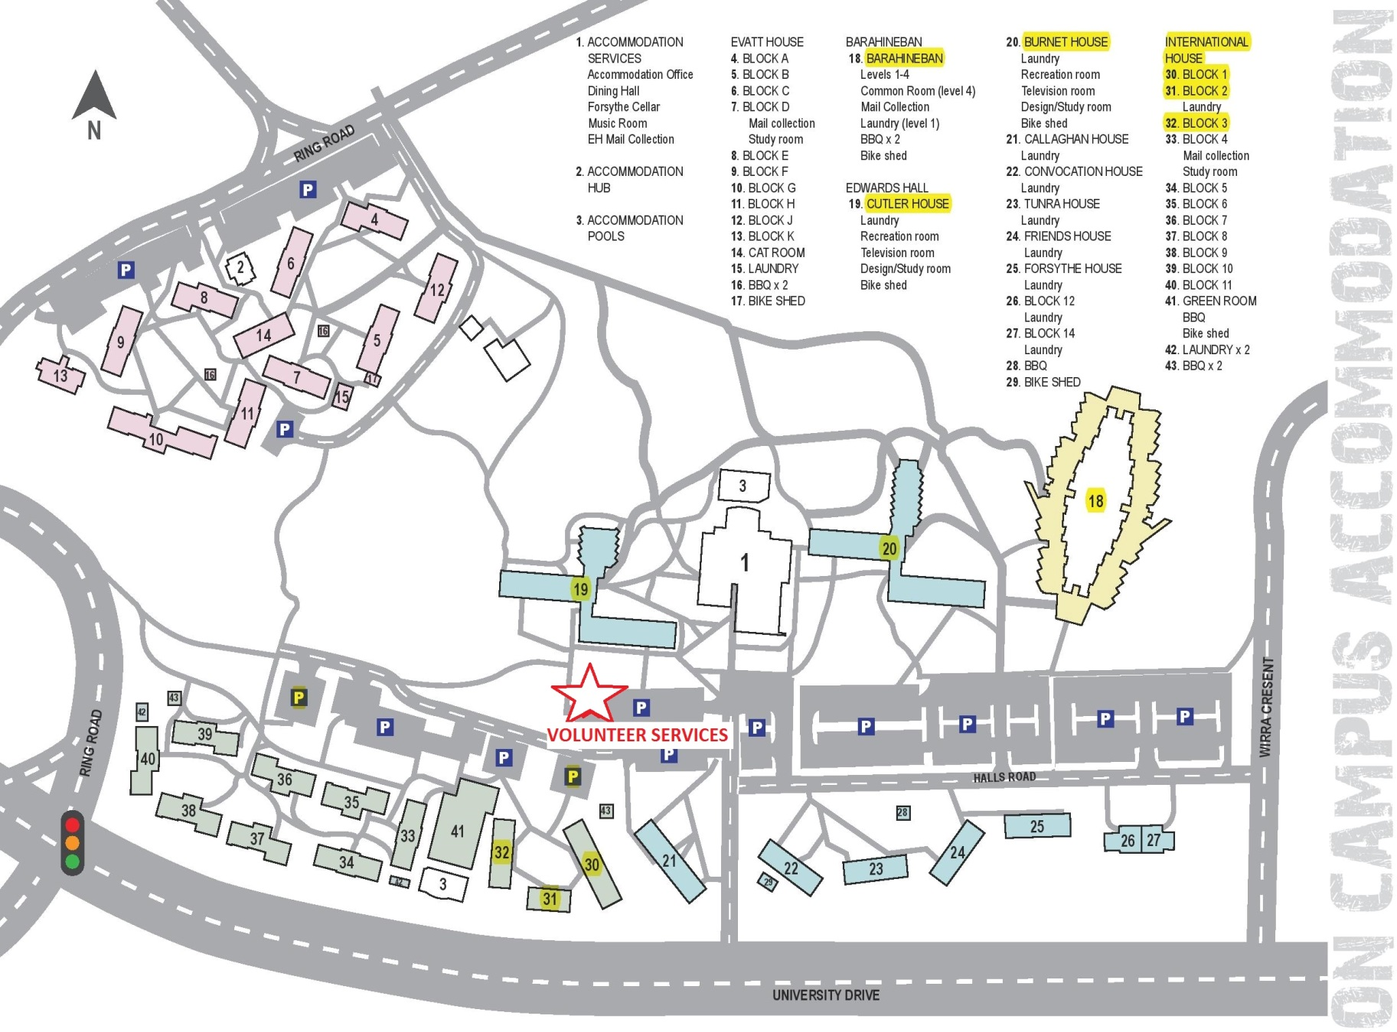

**Events – Myuna Bay Accommodation and Movie Night**

**Venue – Myuna Bay Sport & Recreation Facility**

Address: Wangi Road, Myuna Bay

Public Transport: There is no regular public transport to Myuna Bay

Private Transport: There are sufficient parking facilities at or near the campus accommodation.

Event Information: There will be an ongoing volunteer presence at the athletes’ accommodation throughout the Games, from Friday 5 December through to Thursday 11 December.

On Monday evening 8 December the ICG will be staging a Movie Night, which will be held in the dining hall of the facility, near the accommodation blocks. This event is not open to members of the public

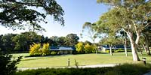

You should check your allocated shifts (within the Job Description section of this booklet) to determine what times you will be required at Myuna Bay.

**

**Event – ICG Opening Ceremony Venue – Speers Point Park**

Address: Park Road, Speers Point

Public Transport: Bus Route 363 travels from Newcastle CBD to Warners Bay, and return. The bus travels close to Speers Point Park.

Refer to [www.131500.com.au](http://www.131500.com.au) for more detailed transport options

Private Transport: There are limited parking facilities at Speers Point Park. It is recommended that you use the *Park & Ride* service by parking your car at Warners Bay and catching a free ICG bus to the Opening Ceremony.

City Team Liaison Officers (CTLOs) will have the opportunity to travel with their team from the accommodation directly to the Opening Ceremony.

Event Information: The Opening Ceremony will be attended by all athletes, coaches, Heads of Delegation and VIPs, and is a public event. There will be over 20,000 in attendance. After the Opening Ceremony, all athletes will leave their seats and will be escorted to a designated area in Speers Point Park to be served dinner. ICG buses will collect the athletes after dinner and transport them to their accommodation.

While the athletes are enjoying dinner, the main stage will be utilised for the annual Newcastle Permanent Carols by Candlelight celebrations.

Event Schedule:

**Date Program Time**

Saturday 6 December Volunteers’ Briefing 4.00pm

Rehearsal 4.30pm

Sunday 7 December Volunteers’ Briefing 3.00pm

Opening Ceremony start 4.30pm

Opening Ceremony finish 7.30pm approx.

Dinner finish 8.30pm approx.

**Event – ICG Beach Experience Venue – Swansea Belmont Surf Lifesaving Club**

Address: 121 Ungala Road, Blacksmiths Beach

Public Transport: Public Bus Routes travel from Newcastle CBD to, and return. The bus travels close to Blacksmiths Beach.

Refer to [www.131500.com.au](http://www.131500.com.au) for more detailed transport options

Private Transport: There are limited parking facilities at Blacksmiths Beach and also plenty of on-street parking near the beach.

Event Information: The ICG Beach Experience will be held on the afternoon of Tuesday 9 December. It will be attended by all athletes, coaches, Heads of Delegation and VIPs. However the event will not be open to the public. The primary role of volunteers will be to monitor the activities to ensure that the children have a safe and memorable experience. Other volunteer roles will include assisting in the provision of catering for the athletes.

Event Schedule:

**Date Program Time**

Tuesday 9 December Volunteers’ Briefing 4.00pm

Beach Experience start 5.00pm

Beach Experience finish 7.30pm approx.

**

**Events – Athletics and Gymnastics Venue – Hunter Sports Centre**

Address: 43 Stockland Drive, Glendale Web: [www.hsc.org.au](http://www.hsc.org.au)

Public Transport: Bus Routes 226 and 363 from Newcastle stop at Stockland Shopping Centre, Glendale, which is only a 400m walk to the Hunter Sports Centre.

Refer to [www.131500.com.au](http://www.131500.com.au) for more detailed transport options.

Located approximately 5 km north of the ICG Event Hub, the Hunter Sports Centre is the only track and field athletics facility between Sydney and Brisbane that meets IAAF standards. The Centre plays host to 110 regional schools, regional and zone competitions as well as State and National athletics events.

The Hunter Sports Centre Gymnastics club is the largest gymnastics club in NSW. The centre includes 2448 square metres of floor space, climbing ropes, foam pit, Olympic size trampolines, sprung floor, and a full set of men’s and women’s artistic gymnastic equipment. All competition apparatus is to Federation International de Gymnastique (FIG) International Competition Standards.

Athletics Event Information: Each city may enter between 2 and 6 athletes of each gender. Disciplines: 100m, 800m (G), 1500m (B), Long Jump, High Jump, Shot Put, 4x100m relay.

Gymnastics Event Information: Each city may enter between 2 and 5 athletes of each gender. Disciplines: Boys – floor, pommel, rings, vault, parallel and horizontal bars. Girls – vault, uneven bars, balance beam and floor exercises



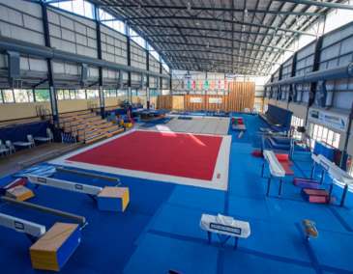

Event Schedule:

**Date Program Time**

Sunday 7 December Volunteers Briefing 9.00am

Athlete Training 10.00am to 2.00pm

Monday & Tuesday Volunteers Briefing 8.00am

Competition (both sports) 9.00am to 3.00pm

Wednesday 10 December Volunteers Briefing (athletics only) 8.00am

Competition (athletics only) 9.00am to 1.00pm

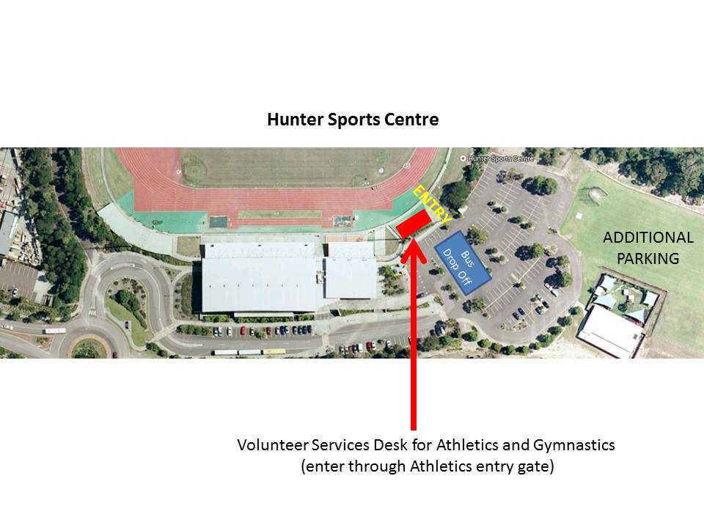

**Event – Swimming Venue – The Forum Sports and Aquatic Centre**

Address: University of Newcastle, off University Drive

Web: <http://www.theforum.org.au/the-forum-sports-and-aquatic-centre-university>

Public Transport: The Forum is located within the University of Newcastle’s Callahan campus. Bus Routes 100, 104, 225 and 226 all travel past the University from several Newcastle suburbs. The Forum is 800m north of the University bus stop. A train service also stops at Warabrook Station. The Forum is 500m south west of Warabrook Station.

Refer to [www.131500.com.au](http://www.131500.com.au) for more detailed transport options.

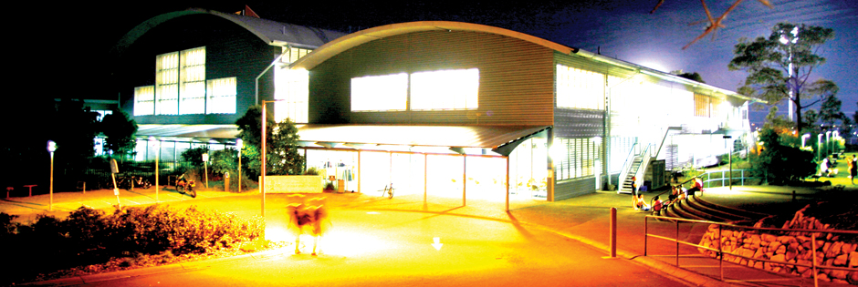

Located 12km north east of the ICG Event Hub, the University of Newcastle Forum Sports and Aquatic Centreis owned and maintained by the University of Newcastle. The Forum boasts personal training rooms, indoor courts and one of the largest indoor climbing walls in Australia. The state of the art indoor 50m pool was a key international training venue for the 2000 Sydney Olympic Games.

Event Information: Competition will be held in freestyle, breaststroke, butterfly, backstroke, individual medley and relays. Each team is permitted to enter between 2 and 4 competitors of each gender. A swimmer may compete in a maximum of 4 events plus 2 relays.

Event Schedule:

**Date Program Time**

Sunday 7 December Volunteers’ Briefing 7.00am

Athlete Training 8.00am to 3.00pm

Monday & Tuesday Volunteers’ Briefing 8.00am

Competition - Heats 9.00am to 3.00pm

Wednesday 10 December Volunteers’ Briefing 8.00am

Competition – Finals and Ceremonies 9.00am to 3.00pm

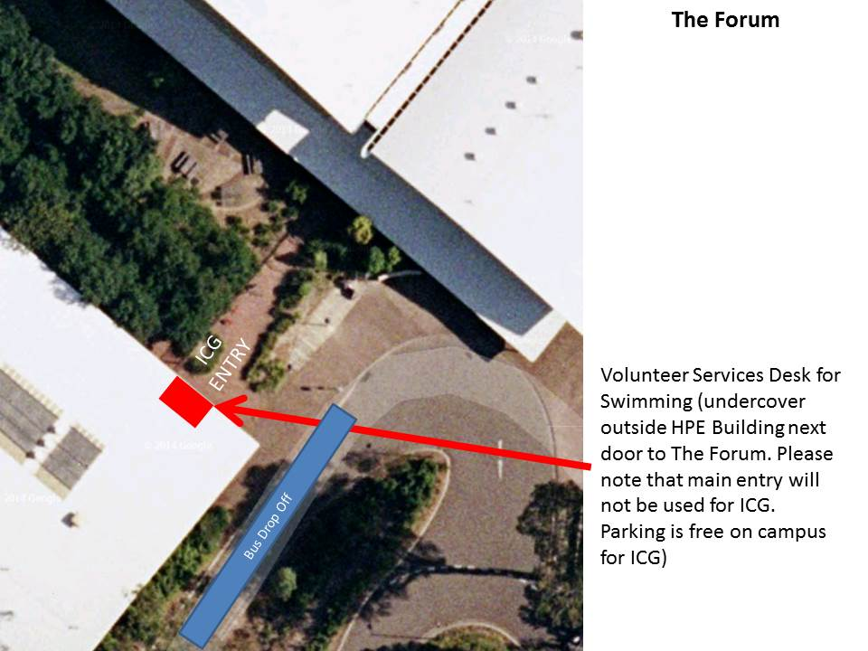

**Event – Golf Venue – Waratah Golf Club**

Address: 456 Lake Road, Argenton Web: [www.waratahgolfclub.com.au](http://www.waratahgolfclub.com.au)

Public Transport: Bus Route 363 travels from Newcastle CBD to Warners Bay, and return. The bus travels past the Golf Club and also close to the Event Hub at Speers Point.

Refer to [www.131500.com.au](http://www.131500.com.au) for more detailed transport options.

 

Located 2.5 km north of the ICG Event Hub, the Waratah Golf Club was the first golf club established in the Newcastle and Lake Macquarie region. The Club represents the proudest traditions in golf, and has a long and distinguished list of members who have gone on to play on the Australian and world stage.

Event Information: Each team may enter a maximum number of 2 girls and 2 boys or a minimum 1 boy and 1 girl. (2+2, 2+1, 1+1, 2+0, minimum 2 athletes and one coach)

Golfers will compete in 2 rounds of 18 holes in individual stroke play. A nominated 2 person team event will be played over 36 holes in conjunction.

Event Schedule:

**Date Program Time**

Sunday 7 December Volunteers’ Briefing 9.00am

Athlete Training 10.00am to 2.30pm

Monday & Tuesday Volunteers’ Briefing 8.30am

Competition 9.30am to 2.00pm

Medal Ceremonies 2.00pm

Wednesday 10 December No Competition

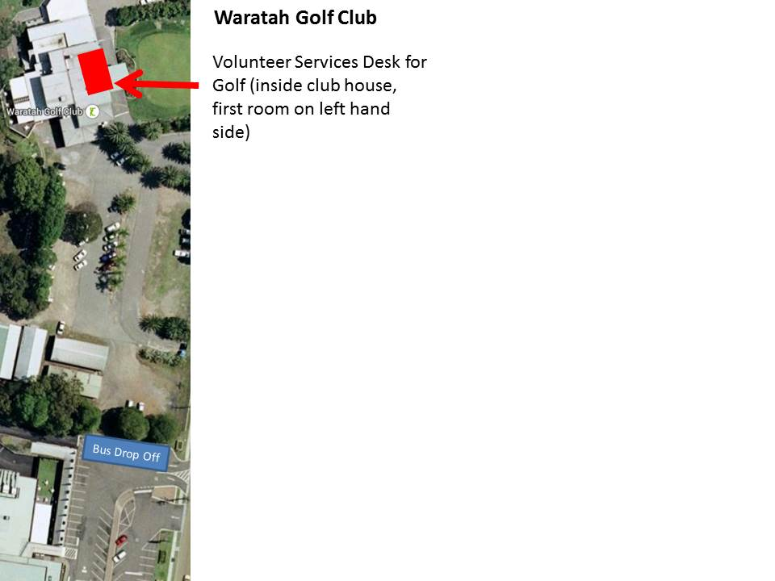

**Event – BMX Venue – Lake Macquarie BMX Club**

Address: Mary Street, Argenton Web: [www.bmxnsw.com.au/lakemacquarie](http://www.bmxnsw.com.au/lakemacquarie)

Public Transport: Bus Route 363 travels from Newcastle CBD to Warners Bay, and return. The bus travels along Lake Road, Argenton past the Mary Street intersection. The BMX track is at the end of Mary Street. The 363 bus also travels close to the Event Hub at Speers Point.

Refer to [www.131500.com.au](http://www.131500.com.au) for more detailed transport options.



Located 3 km north of the ICG Event Hub, the Lake Macquarie BMX Club is the largest BMX club in NSW, boasting over 250 members. The track has recently undergone a million dollar upgrade to lift its status to a standard that now allows it to host sanctioned international events. The club was established in 1980 and moved to its current site in 1990.

Event Information: The BMX competition will run in conjunction with a regional championship competition, which will ensure a large participation atmosphere and will allow the ICG competitors to view a full scale BMX event. Each team may enter a maximum of 5 girls and 5 boys or a minimum of 1 girl and 1 boy. All ICG athletes will compete in the 20” class.

Event Schedule:

**Date Program Time**

Sunday 7 December Volunteers’ Briefing 9.00am

Athlete Training 10.00am to 2.00pm

Monday Volunteers’ Briefing 8.00am

Athlete Training 9.00am to 3.00pm

Tuesday REST DAY

Wednesday 10 December Volunteers’ Briefing 8.00am

Competition 9.00am to 2.00pm

Medal Ceremonies 2.30pm

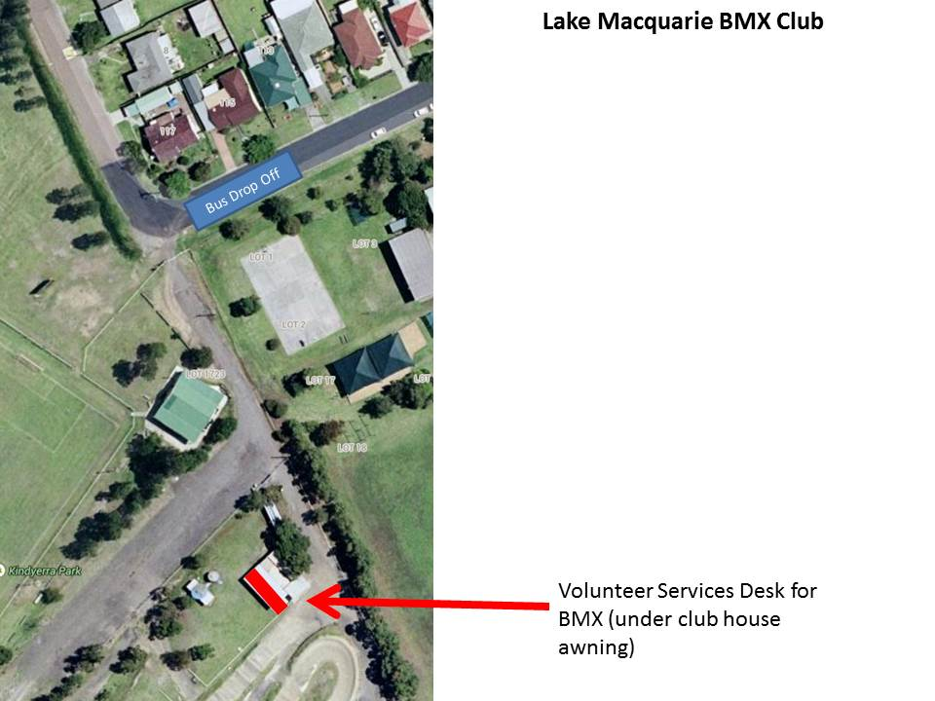 **Event – Sailing Venue – Belmont 16 Foot Sailing Club**

Address: The Parade, Belmont Web: [www.16s.com.au](http://www.16s.com.au)

Public Transport: Bus Routes 310 from Newcastle and 313 from Charlestown travel past the Sailing Club. Bus Routes 317 or 322 from Newcastle travel down the Pacific Hwy, which is an 800m walk from the Sailing Club.

Refer to [www.131500.com.au](http://www.131500.com.au) for more detailed transport options.

Located approximately 12 km south of the ICG Event Hub, Belmont 16ft Sailing Club is the top 16ft sailing club in Australia. The Club was formed in 1920, and since then the Club has expanded to become the major licensed club in eastern Lake Macquarie.

In January 2014 the Club hosted the International Contender World Championship. The Club is the major supporter of the *Sailability* Program, which allows people with physical and intellectual disabilities to enjoy the sport of sailing. Many World Champions and Olympians learned their sport under the guidance of the Club in the beautiful waters of Belmont Bay.

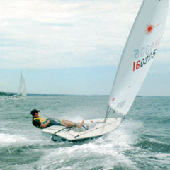

Event Information: The Sailing Competition is open to competitors in the International Optimist class and the International Laser 4.7 class. Each class will be sailed over a trapezoid course. Each team may consist of one Optimist sailor (boy or girl) and one Laser 4.7 sailor (boy or girl). Entry is restricted to no more than 20 cities in each class.

Event Schedule:

**Date Program Time**

Sunday 7 December Volunteer Briefing 9.00am

Athlete Training 10.00am to 2.00pm

Monday & Tuesday Volunteer Briefing 9.00am

Athlete Registration and Briefing 10.00am to 10.30am

Competition (all classes) 11.00am to 3.00pm

Wednesday 10 December Volunteer Briefing 9.00am on the waterfront

Athlete Registration and Briefing 10.00am to 10.30am

Competition (all classes) 11.00am to 2.30pm

Medal Ceremonies 3.00pm

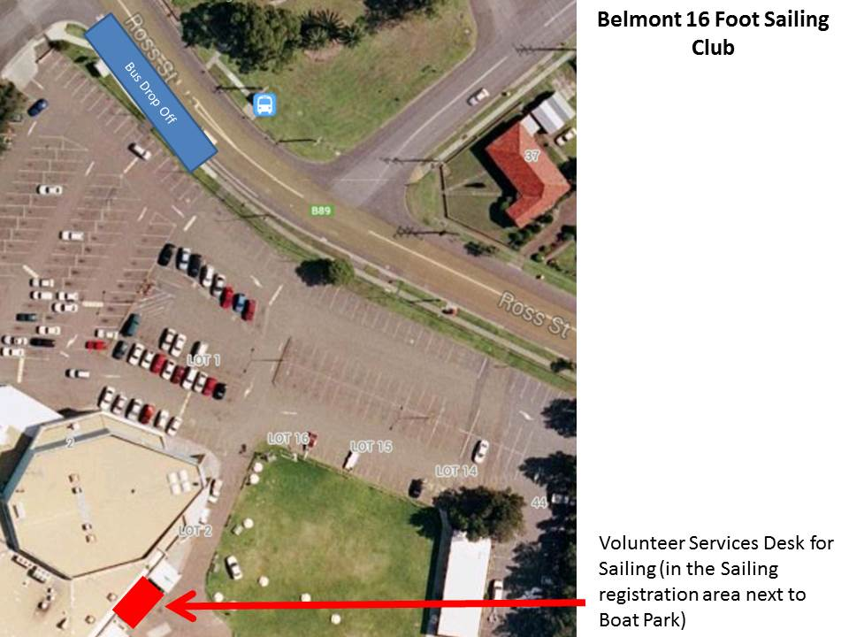

**Event – Water Polo Venue – Speers Point Pool**

Address: Park Road, Speers Point Web: <http://www.lakemac.com.au/recreation/swim-centres/speers-point>

Public Transport: Bus Route 363 travels from Newcastle CBD to Warners Bay, and return. The bus travels close to the Speers Point Pool, which is right next door to the Event Hub at Speers Point.

Refer to [www.131500.com.au](http://www.131500.com.au) for more detailed transport options.

Located 100m east of the ICG Event Hub, the Speers Point Pool is owned and maintained by Lake Macquarie City Council. The Lake Macquarie Dolphins Water Polo Club is proud to be hosting the water polo competition.

The Dolphins compete in the Newcastle Water Polo Competition, and boast over 70 enthusiastic members.

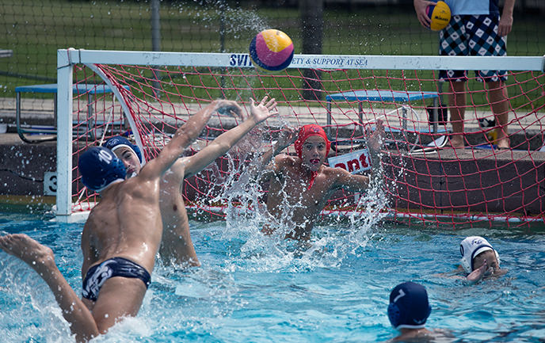

Event Information: Each squad will consist of between 9 and 13 players, plus a coach. Teams will consist of seven players, including the goalkeeper.

Event Schedule:

**Date Program Time**

Sunday 7 December Volunteers’ Briefing 9.00am

Athlete Training 10.00am to 3.00pm

Monday 8 December Volunteers’ Briefing 8.30am

Competition - Heats 9.30am to 3.00pm

Tuesday 9 December Volunteers’ Briefing 8.30am

Competition - Heats 9.30am to 2.00pm

Wednesday 10 December Volunteers’ Briefing 8.30am

Competition - Finals 9.30am to 12.30pm

Medal Ceremonies 1.00pm

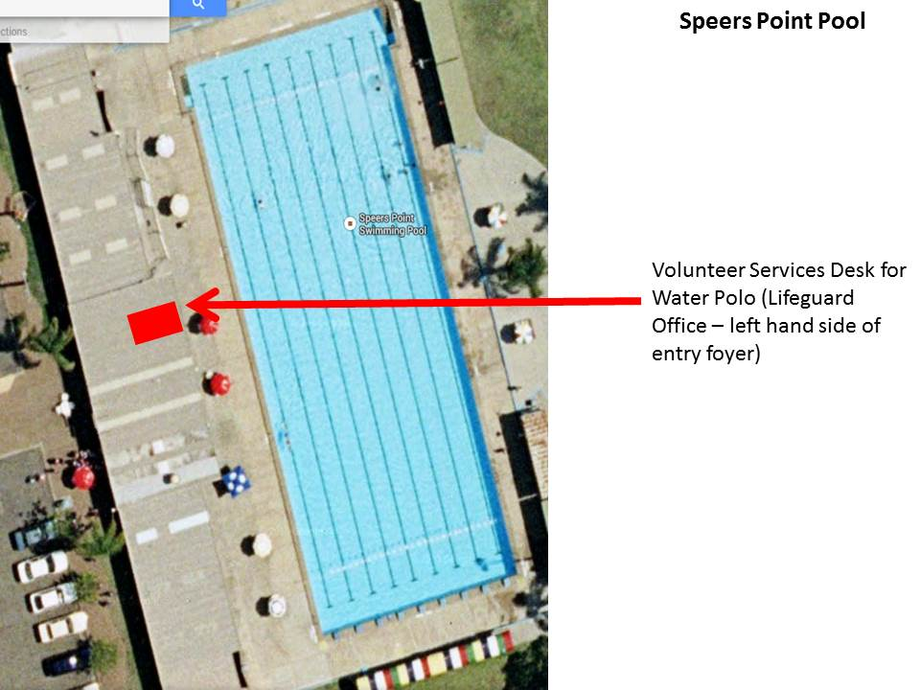

**Event – Football Venue – Lake Macquarie Regional Football Facility**

Address: 3 Main Road, Boolaroo Web: [www.macquariefootball.com.au](http://www.macquariefootball.com.au)

Public Transport: Bus Route 363 travels from Newcastle CBD to Warners Bay, and return. The bus travels close to the Football fields and also the Event Hub at Speers Point.

Refer to [www.131500.com.au](http://www.131500.com.au) for more detailed transport options.

Located just 200m north of the ICG Event Hub, the Lake Macquarie Regional Football Facility is a brand new complex, and is proud to host the ICG Football competition as its first major event.

The complex has ten 5-a-side football pitches, two full-size synthetic pitches, training facilities and a state-of-the-art administrative building.

The competition will be played on the full size pitches, with the 5-a-side courts available for training. Pitch size is nominally 65m by 45m.



Event Information: Each squad will have between six and eight players, and one coach. Teams will consist of six players, including goalkeeper. The boys tournament will consist of up to 20 teams and the girls tournament will consist of up to 16 teams. Each game will involve 2 x 20min halves. Teams will compete in pool rounds, then proceed to Quarter finals, Semi-finals and a Final.

Event Schedule:

**Date Program Time**

Sunday 7 December Volunteers’ Briefing 9.00am

Athlete Training 10.00am to 2.30pm

Monday 8 December Volunteers’ Briefing 7.30am

Competition - Heats 8.30am to 4.30pm

Tuesday 9 December Volunteers’ Briefing 7.30am

Competition - Heats 8.30am to 3.30pm

Wednesday 10 December Volunteers’ Briefing 7.30am

Competition - Finals 8.30am to 3.00pm

Medal Ceremonies 3.30pm

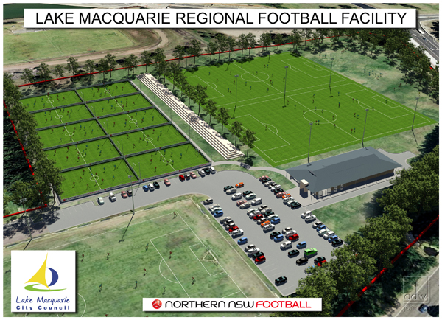

**Event – ICG Closing Ceremony Venue – University Forum, No. 2 Oval**

Address: Off University Drive, Callaghan

Public Transport: Bus Routes 100, 104, 225 and 226 all travel past the University from several Newcastle suburbs. A train service also stops at Warabrook Station. The campus accommodation is 1km south of Warabrook Station.

Refer to [www.131500.com.au](http://www.131500.com.au) for more detailed transport options

Private Transport: There are parking facilities at or near the campus accommodation.

Event Information: The ICG Closing Ceremony will be a celebration of the conclusion of the 2014 Games. It will include a formal closing ceremony followed by a concert. All children, coaches, Heads of Delegation and VIPs will be attending.

***All volunteers are invited to attend!***

Otherwise, the event will be closed to the public.

Volunteers who are rostered on for the event will be required to monitor the perimeter to ensure that the children have a safe and memorable evening, as well as providing services to the VIP function.

Event Schedule:

**Date Program Time**

Wednesday 10 December Volunteers’ Briefing 6.00pm

Athletes arrive 7.00pm

Closing Ceremony start 7.30pm

Closing Ceremony finish 9.30pm approx.

C:\Users\djwilliams\AppData\Local\Microsoft\Windows\Temporary Internet Files\Content.IE5\RR56O8DT\MC900232522[1].wmf

**Incident Report Form - Volunteers**

*Personal information will not be disclosed to third parties without your consent unless required by law.*

|  |  |  |  |  |  |  |  |  |  |  |  |  |  |  |  |  |  |  |  |  |  |  |  |  |  |  |
| --- | --- | --- | --- | --- | --- | --- | --- | --- | --- | --- | --- | --- | --- | --- | --- | --- | --- | --- | --- | --- | --- | --- | --- | --- | --- | --- |
| **YOUR Details** | | | | | | | | | | | | | | | | | | | | | | | | | | |
|  | |  | | | | | |  | | |  | | | | | | |  | | |  | | |  | | |
| First name: | |  | | | | | | Last name: | | |  | | | | | | |  | | |  | | |  | | |
|  | | | | | | | | | | | | | | | | | | | | | | | | | | |
|  | | |  | | | | |  | |  | | | | | | Male | | | | Female | | |  | | | |
|  | | | | | | | | | | | | | | | | | | | | | | | | | | |
| Functional area/ sport: | | | | | |  | | | | | | | | | | |  | | | | | | | |  | |
|  | | | | | | | | | | | | | | | | | | | | | | | | | | |
| Event role: (specify)  Volunteer  Athlete  Official  Staff  Other | | | | | | | | | | | | | | | | | | |  | | | | | | |  |
|  | | | | | | | | | | | | | | | | | | | | | | | | | | |
| Contact telephone number: | | | | | | |  | | | | | | Your Signature | | | | | |  | | | | | | |  |
|  | | | | | | | | | | | | | | | | | | | | | | | | | | |
| **Type of incident:** | | | | | | | | | | | | | | | | | | | | | | | | | | |
|  | | | | | | | | | | | | | | | | | | | | | | | | | | |
|  | Injury | | | | | | | | | | | | | | Damage to vehicle/equipment | | | | | | | | | | | |
|  | | | | | | | | | | | | | | | | | | | | | | | | | | |
|  | Hazard/risk | | | | | | | | | | | | | | Theft/robbery | | | | | | | | | | | |
|  | | | | | | | | | | | | | | | | | | | | | | | | | | |
| Date of incident: | | | | |  | | | |  | | | | | Time of incident: | | | |  | | | | am / pm (circle) | | | | |
|  | | | | | | | | | | | | | | | | | | | | | | | | | | |
| Location of incident: (venue name if applicable) | | | | | | | | | | | |  | | | | | | | | | | | | | |  |
|  | | | | | | | | | | | | | | | | | | | | | | | | | | |
| Further notes: | | | |  | | | | | | | | | | | | | | | | | | | | |  | |
|  | | | | | | | | | | | | | | | | | | | | | | | | | | |
|  | | | |  | | | | | | | | | | | | | | | | | | | | |  | |
|  | | | | | | | | | | | | | | | | | | | | | | | | | | |

***Notes:***

**

**